1. Logged in to Apple account with Apple ID and Password.
2. Tried to choose [Certificates, Identifiers & Profiles](https://developer.apple.com/account/resources) as suggested in the documents.
3. But it asked to login to apple developer account first and asked to go through the details.

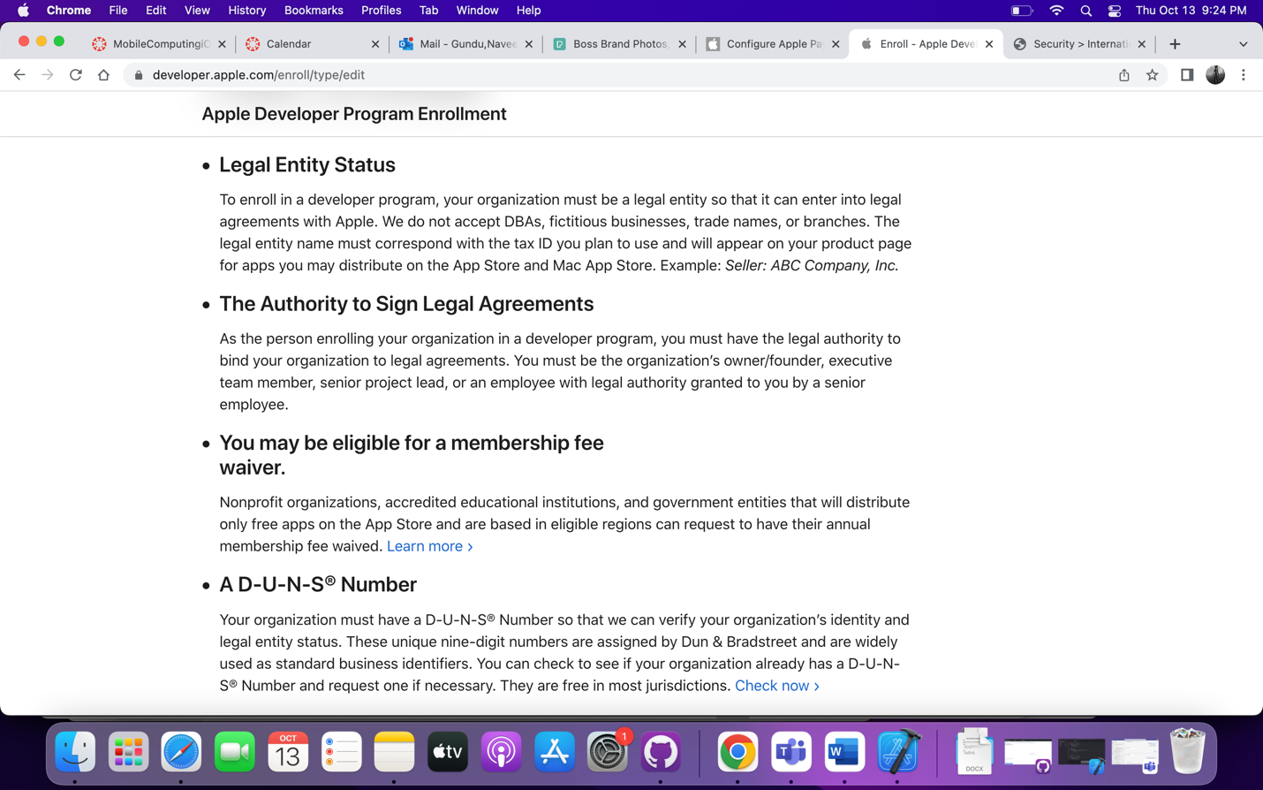

1. Tried to register for an apple developer account but it is asking to but it for one year.

